* A maximum of four partitions can be placed on any hard disk. These are sometimes called *primary partitions*. The limitation of four is one that is imposed on the system by the way that the master boot record is structured.
* Only one partition may be designated, at any given time, as *active*. That partition will be used for booting the system. [See here](http://www.pcguide.com/ref/hdd/file/struct_Active.htm)for more on active partitions and switching active status between partitions.
* DOS (and the operating systems that depend on it for booting, which includes all consumer Windows operating systems) will only recognize the active primary partition. Any other primary partitions will be ignored.
* One of the four partitions may be designated as an *extended DOS partition*. This partition may then be subdivided into multiple*logical partitions*. This is the way that two or more logical DOS volumes can be placed on a single hard disk.

Alright, I realize that this is somewhat confusing, so let's take a look at some examples of systems, to show you how this scheme is used:

* **Single Partition Windows PC:** Many PCs have all of their disk space made into a single partition, and use one of the FAT file systems. Such a machine would have just a single FAT primary partition on it, and nothing else. The other three "slots" for partitions on the disk would be empty.
* **Multiple Partition Windows PC:** To use more than one partition at a time on a DOS/Windows system, two partitions are used. One is a regular DOS primary partition (which becomes the "C:" drive). The other is the extended DOS partition. Within the extended DOS partition, all the other logical drives are created. So a drive with four logical drive letters would have the first (C:) be the active primary partition, and the other three (D:, E: and F:) would be logicals within the extended DOS partition.
* **Multiple Operating System PC:** A system with multiple operating systems could use one primary partition for each of up to four different file systems.

Câu 3:

Bước 1: Dùng vmware add một hard disk mới (chọn allocate all disk space now), như hình dưới ta thấy harddisk là disk /dev/sdb: 1073 MB và dòng disk /dev/sdb doesn’t contain a valid partition table là do chưa sử dụng fdisk để chia partition.

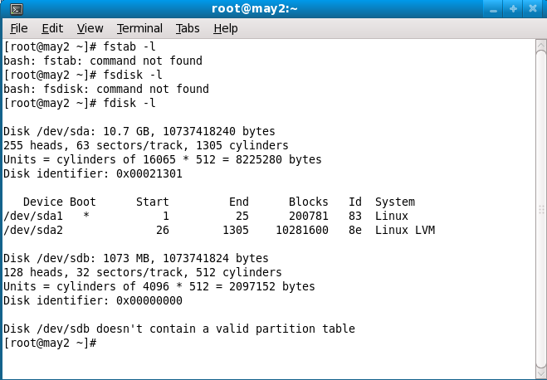

Bước 2: fdisk /dev/sdb (do bai` nay keu logical partition nen ta can sua lai la extended)

Chọn n để add new partition, ta chọn p, partition number (1-4) nếu chọn 1 thì sau đó fdisk sẽ ra sdb1. Ta chọn 1. First cylinder ta chọn 1, last cylinder ta ghi +100M

Xong ta chọn w để write/save kết quả. Nếu không muốn save ta chọn q (quit)

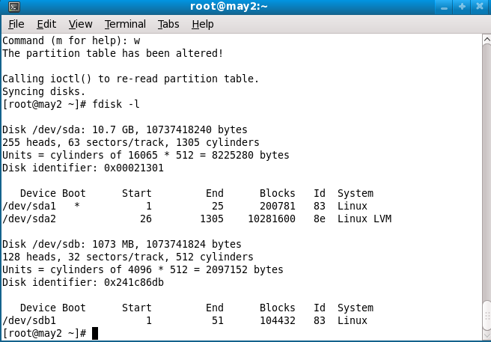

B3: Dùng mkfs –t ext3 /dev/sdb1 để format định dạng ext3.

B4: Dùng partprobe để info OS of partition table changes. Sau khi gõ partprobe thì trong /media sẽ xuất hiện 1 disk mới.

B5: Mount

mkdir /backup

Mount /dev/sdb1 /backup

Câu 4

The /etc/fstab file contains the partitions and mount points

specified, this is important to add entries to this file so

that the partition is automatically mounted after each reboot.

# vi /etc/fstab

Append as follows

/dev/sdb1 /backup ext3 defaults 1 2

Reboot lại dùng lệnh mount để check.